Price elasticity
This is a brief – and the only - write-up in existence about price elasticity, as currently implemented in EwE6.

Original email
Villy’s original email of 19 March 2011 where he introduced the price elasticity concept:
Here's a neat new thing for the to-do (I.e., not a drop-everything-thing), I came to think of:
We'll add "Price elasticity" to Ecosim.
In the Navigator after Fishing mortality before fleet dynamics, add "Price elasticity"
When clicking it is shows a form exactly like the mediation.
X-axis title on the top plot becomes: Landings (weighted by value)
Can we make the color of the plot green instead of blue?
Define X-axis: X-axis title becomes Landings
On the pop up form: Define biomass percentage becomes Define groups impacting price. List here fleet – group combinations; when a fleet – group is selected, it should get a weight = off vessel price entered automatically. Also change the "mediating group" in the small lower right plot to "Group".
Make an "Apply price elasticity"; it should open a form with fleets on the top and groups in row (similar to the Landings form in Ecopath), with only those groups that have landings being selectable.
Multiplier is always applied to off-vesselprice anywhere this is used in Ecosim or Ecospace or MSE or Fishing Policy Search or anywhere else (but not in Ecopath baseline of course).
We calculate the multiplier in Ecosim, by calculating the landings (not catches) x off-vessel price for the "mediating" group(s), compare these to the baseline. There may be more than one group selected, so we actually compare the value (landings x off-vessel price) rather than the landings.
The multiplier we get from looking up on the mediation shape (which should be scaled to 1 in Ecosim baseline) is going to be multiplied onto the off-vessel price in all calculations in Ecosim.
Simple and it will open new doors for economic calculations.

Implementation in EwE
We have implemented this functionality largely as outlined in the email:
Elasticity is based on landings (Figure 1) and off-vessel price (Figure 2).
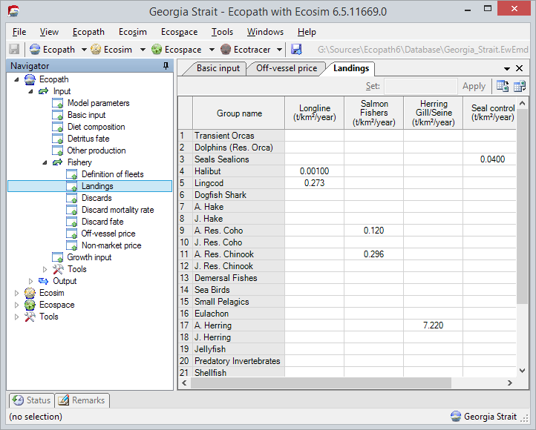
Figure 1 - EwE landings
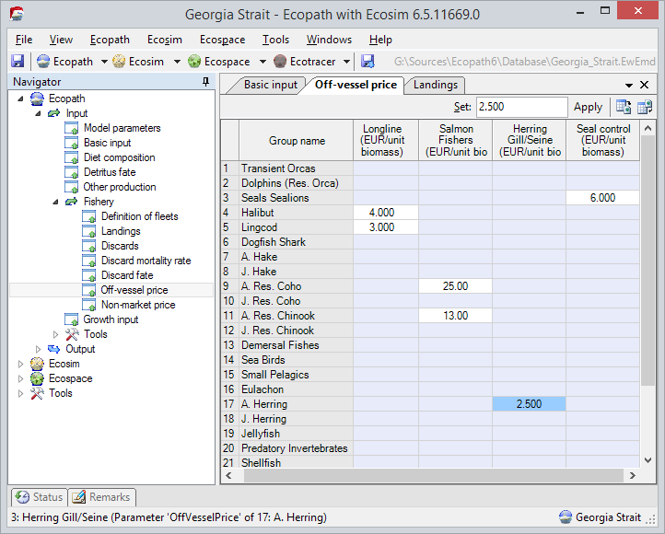
Figure 2 - EwE off-vessel price
Users configure price elasticity through the Ecosim > Price Elasticity node in the navigation tree (Figure 3). In this form users define elasticity curves or ‘shapes’, and use these shapes to determine how (combinations of) landings affect the price of a given landing.
The procedure is as follows:
- Define one or more price elasticity mediation curves, or bluntly called ‘shapes’ in EwE. As with every shape interface in EwE, users can alter the contour of shapes by sketching with a mouse, by Copy / Pasting values into the ‘Values’ interface, or by selecting a mathematical primitive in the ‘Change Shape’ interface. The result is always stunning (Figure 3).
The dashed blue line can be moved with the mouse cursor, and indicates the mediation baseline point – the point where the price equals the Ecopath base value.
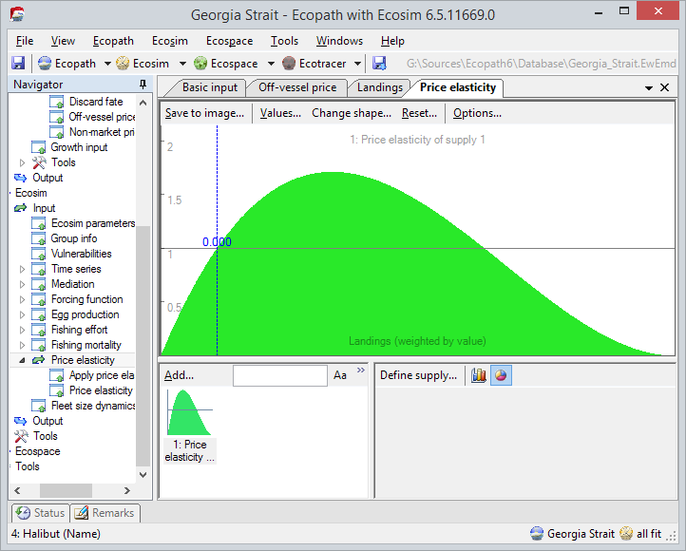
Figure 3 - Ecosim price elasticity interface
- Select the supply to drive the prices via a mediation curve. To do so, select a curve in the price elasticity interface and press ‘Define Supply’. This opens – surprisingly - the EwE ‘Define Supply‘ form (Figure 4). Here, one or more landings (supplies) can be assigned and weighted to drive the prices using the selected curve.
Select an available landing and press the arrow that points right. The landing is added as a price driver with a relative weight equal to the off-vessel price of that landing. The weights can be modified.
The pie chart shows the weighted landed amounts, and thus provides a graphical overview how each landing contributes to overall price elasticity. The pie segments obtain the colour from the landed group.
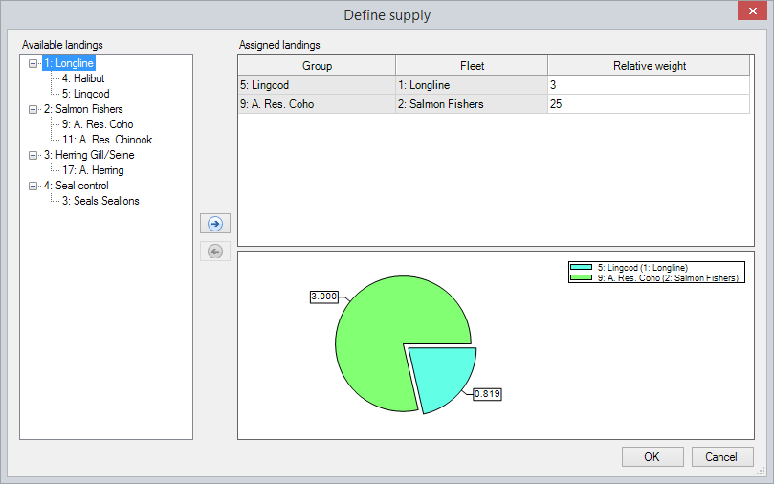
Figure 4 - EwE ‘Define Supply’ interface
- Once the ‘Define Supply’ form is closed, the main Price Elasticity form will update to display supply assigned to the selectedshape when the shape is selected. The shape itself will display the weighted supply total at the Ecopath mediation base line point (Figure 5, dotted blue line).
Now, the supply must be applied to a landing to drive price elasticity. This is done via the ‘Apply Price Elasticity’ node in the navigation tree, which opens the form shown in Figure 6.
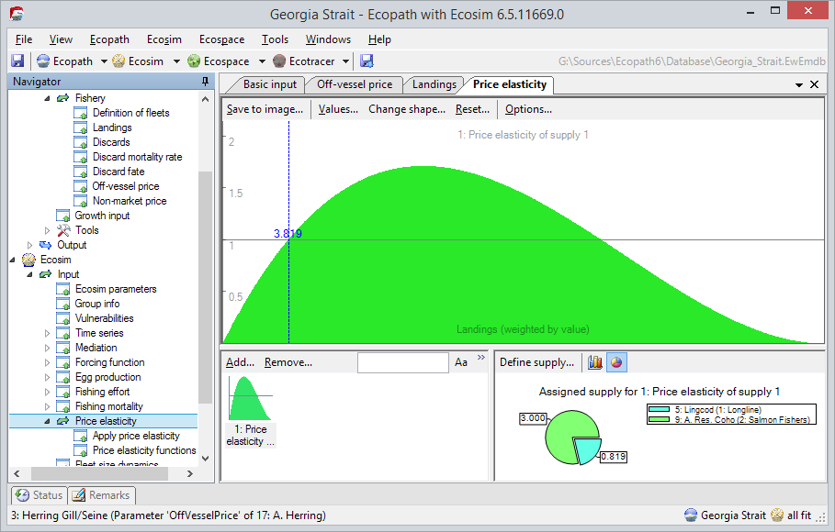
Figure 5 – Defined supply for an elasticity curve
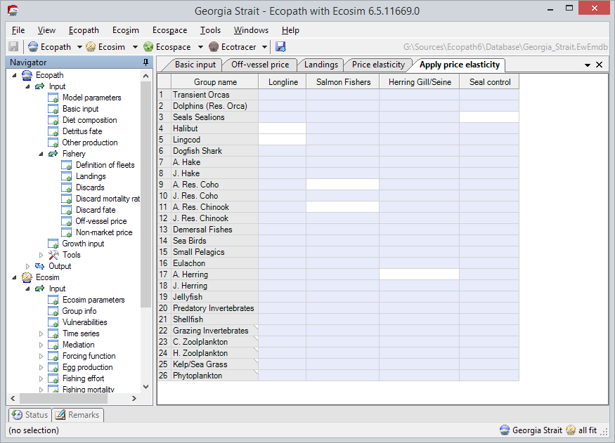
Figure 6 - EwE 'Apply Price Elasticity' interface
- To apply price elasticity to a landing, now click a landing in the ‘Apply price elasticity’ interface and select a supply curve that was configured in the previous steps.
Elasticity is now applied and used throughout EwE.
Note, however, that EwE does not yet have an explicit way to show how prices change. EwE will need this functionality, both in a plot that shows changing off-vessel prices, and written to CSV file when Ecosim auto-saves information.

